**



|  |  |
| --- | --- |
| Name student (incl. student number): | Name : Dimitar Rangelov  Student Number : 445392 |
| Name client: | REV'IT! Sport International B.V. -  Jorrit Memel |
| Name tutor: | Jenny Hesse |
| Names group members: | Harold Kip(327132)  Isabel Wesselink (434129)  Femke Visser(435542)  Le Van Hoang Minh (467475) |
| Project name: | Testing device membrane fabrics for motercycling |
| Project number: | L.26195 |

1. *What does my client think of our delivered results?*

|  |
| --- |
| Feedback from REV’IT |

1. *What does my tutor think of my contribution to the group process?*

|  |
| --- |
| Feedback tutor: Jenny Hesse |

1. *What do my group members think of my contribution to the group process and the results?*

|  |
| --- |
| Feedback group members |

*Please add the pieces of evidence to this document.*

Table of Contents

1. Words List 3

2. Feedback from tutor 4

3. Feedback from the company: REVI’T 5

4. Feedback from my group members 6

5. The assaigment 7

6. Final Product 8

7. Assessment rubic 9

8. Project Plan 11

9. Technical Research 31

# 1. Words List

|  |  |
| --- | --- |
| Arduino | Arduino is very small mini computer based on easy-to-use hardware and software. |
| Humidity | Humidity is the concentration of water vapour present in air. |
| Breathability | Air permeability is the ability of a fabric to allow air to pass through it. While air permeable fabrics tend to have relatively high moisture vapor transmission, it is not necessary to be air permeable to be breathable. |

# 2. Feedback from tutor

COMING SOON!

# 3. Feedback from the company: REVI’T

COMING SOON!

# 4. Feedback from my group members

COMING SOON!

# 5. The assaigment

## 5.1 Introduction organization

REV'IT! Sport International designs and develops fashionable riding gear for motorcyclists. We work from our offices in Oss and New York. REV'IT! is a leading brand that produces the highest quality functional riding apparel available in more than 70 countries. Passionate motorcycle riders all over the world are wearing our brand.

# 6. Final Product

COMING SOON! AFTER RELEASE THE FINAL PRODUCT.

# 7. Assessment rubic

|  |  |  |  |
| --- | --- | --- | --- |
| **Assessment criterium** | **How would you grade yourself?** | **Indicate the evidence provided and explain why this evidence is relevant. \*** | **If the evidence indicated is part of a group project, describe your specific part of the group project here.** |
| 1. The student conducts research using a suitable research and design model and substantiates the choice of model and the steps taken. | I think I scored excellent  Because I am making researches, after that discuss it with my team. After that add their ideas. And after that making experiments. | I showed this by Evidence 6. In the evidence are visible choices and design models and overall the evidence 6 is technical research. | My part in this is writing evidence 6 and making practical experiments. |
| 1. The student collects, analyses, and processes relevant information in a traceable manner. | I think I scored excellent because I analyses and process the information in my Evidence 6 in traceable manner. | I showed this by Evidence 6.  In the evidence are visible the analyses and is it example for traceable manner. | My part in this is writing evidence 6 in traceable way. |
| 1. The student applies knowledge from their own particular discipline and substantiates their choices. | I think I scored excellent. Because I use knowledge from my specialty. | I showed this by Evidence 6.  In the evidence I am applying knowledge from my speciality. | My part in this is writing evidence 6 and making experiments and using my knowledge from my specialty. |
| 1. The student has provided an innovative solution or problem-solving approach for the client. | I think I scored excellent. I am providing the client really clear problem solving approach. And from his side everybody are happy about it. | I showed this by Evidence 6. The evidence is a problem solving approach for the client. | My part in this is writing evidence 6 in which I am providing innovative solutions and problem solving. |
| 1. The student communicates in a respectful, purposeful, and professional manner with all internal and external stakeholders. | I think I scored excellent because I am keeping professional manner to the client and trying to be respectful with the members of my team. | I showed this by Evidence 2 and 4. We respect the work of other people. Evidence 4 is showing the proffesional way how we communicate with external stakeholders. | My part in this is the person who is helping in the communication between the team and client when is matter of technical knowledge. |
| 1. The student takes responsibility within the group for the solutions and partial solutions as well as the processes. | I think I scored excellent because I also help and study from other people with other specialties than mine. Also I am doing my responsibilities excellent. | I showed this by Evidence 3.  This is picture from our project plan that is representing our roles and responsibilities. This is the closest example what we are doing in this project. | My part in this is Embedded Engineer and Software Engineer. |
| 1. I The student describes how they have looked at the project/question from the perspective of another discipline and what this means for the choices that were made. | I think I scored excellent because I am always trying to discuss the solutions that I doing with other specialties. Also I am trying to put their ideas in the real product. | I showed this by Evidence 5. Our main questions are made from the perspectives of all the specialties. Also Evidence 6 was provided to the team to explain the electrical work. | My part in this is making the question with team. I gave Ideas electrical engineering. I made Evidence 6 to explain my work step by step and also to request a feedback from other specialties. How they see these solutions. |
| 1. The student reflects on their actions and adjusts these actions based on this reflection. | I think I scored excellent because I fix all parts of project plan after the feedback. | I showed this by Evidence 2. This is picture from whatapp how we divide again the parts for project plan. | My part in this is Problem Analysis, Research Objectives, Roles and Responsibilities. |

* ) Please add pieces of evidence (or a reference) to this document

# 8. Project Plan

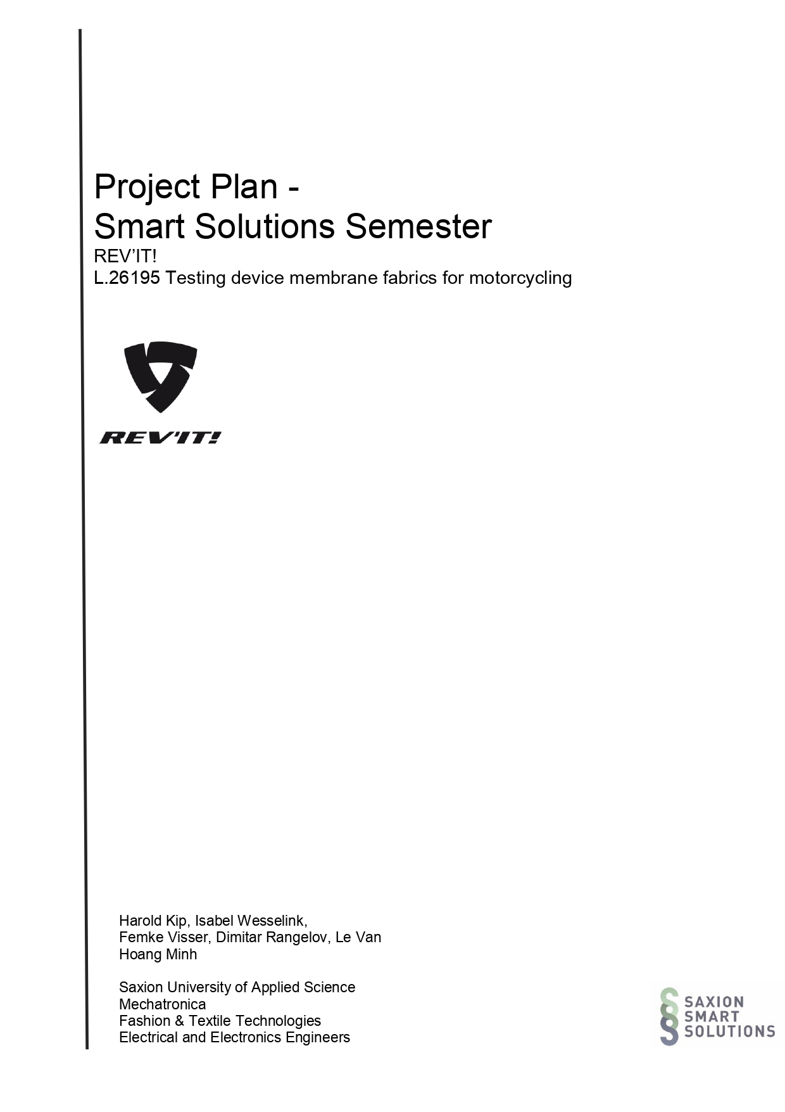

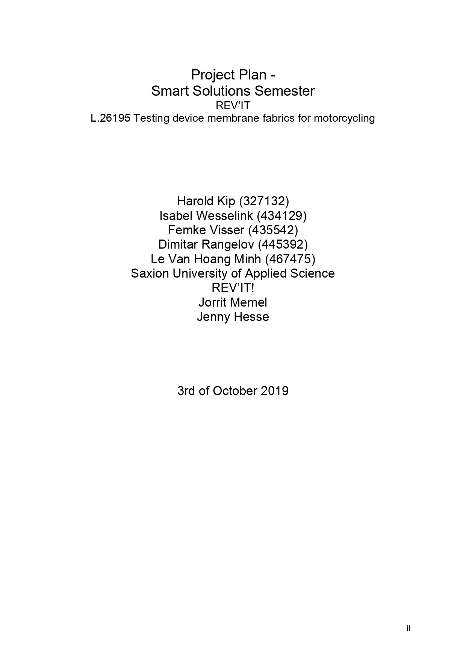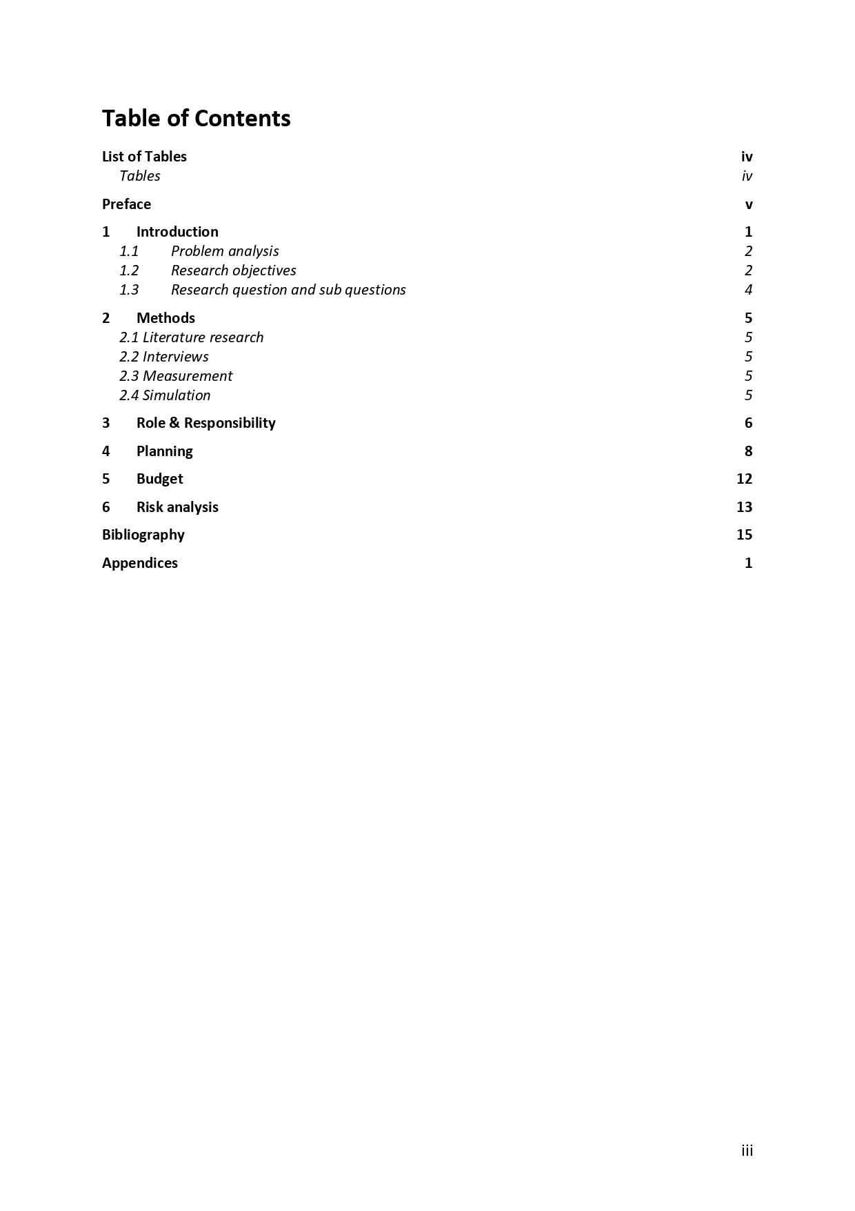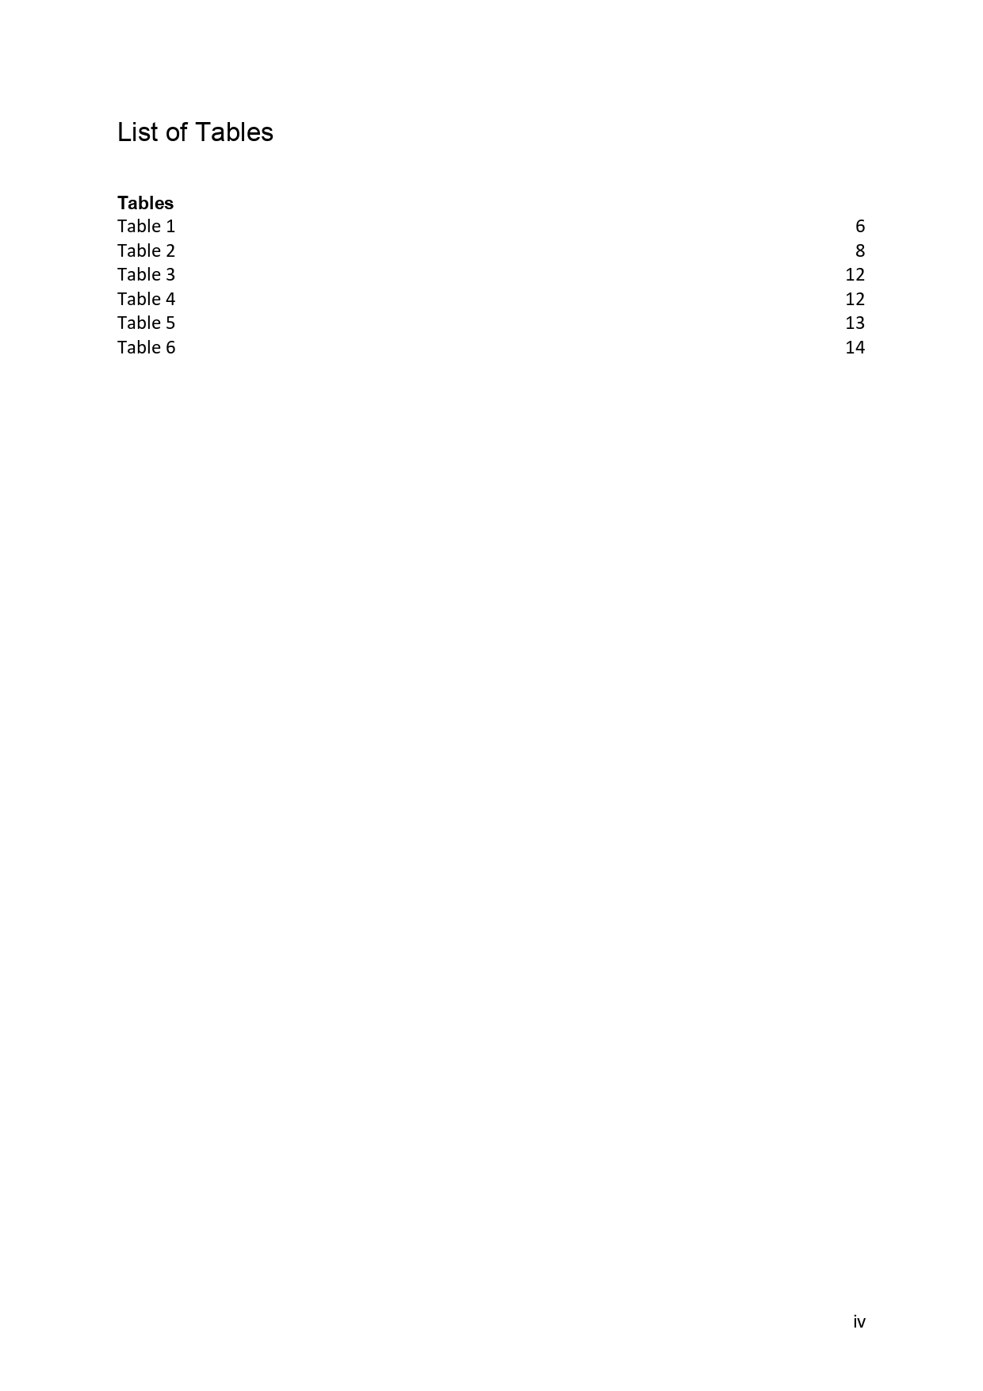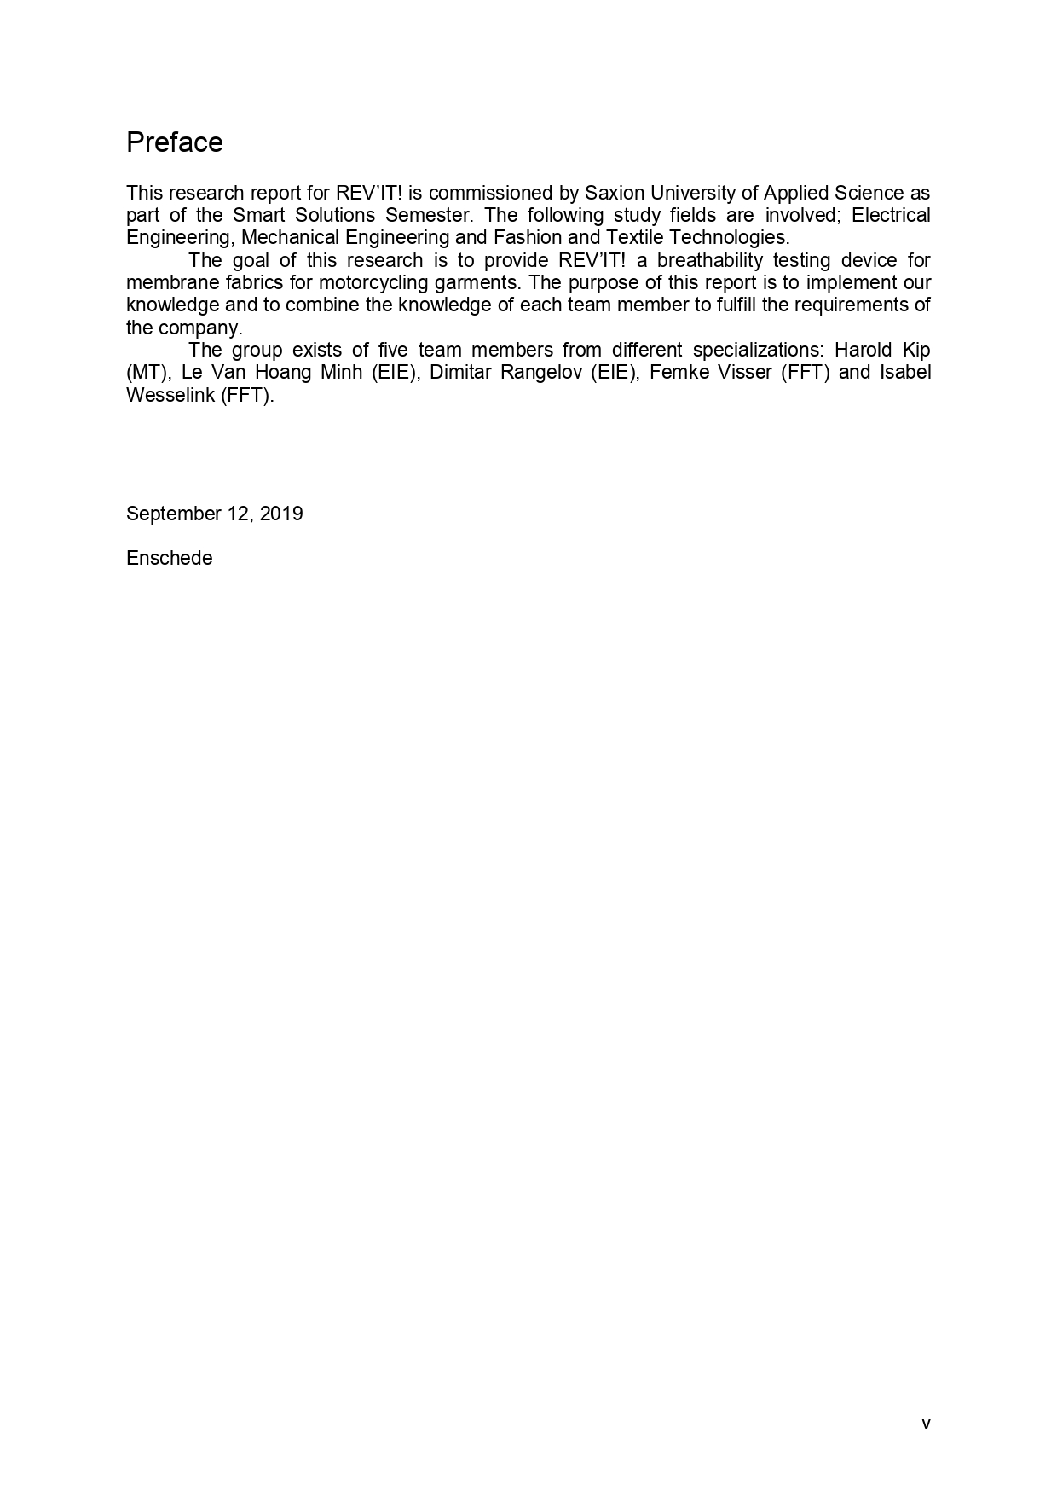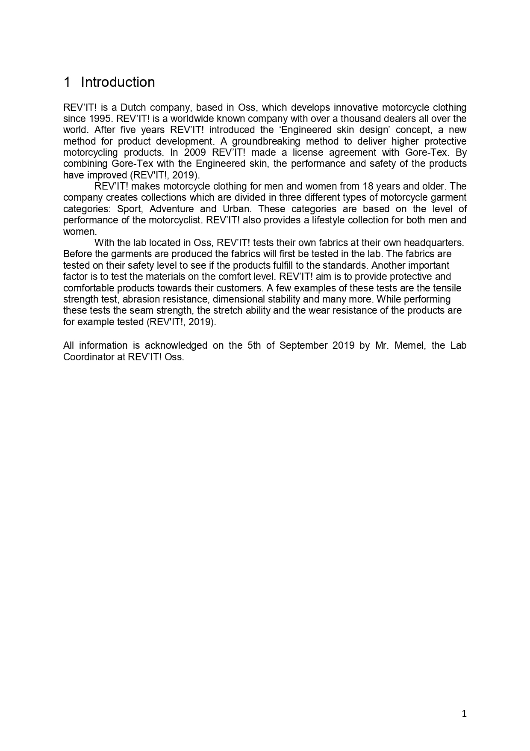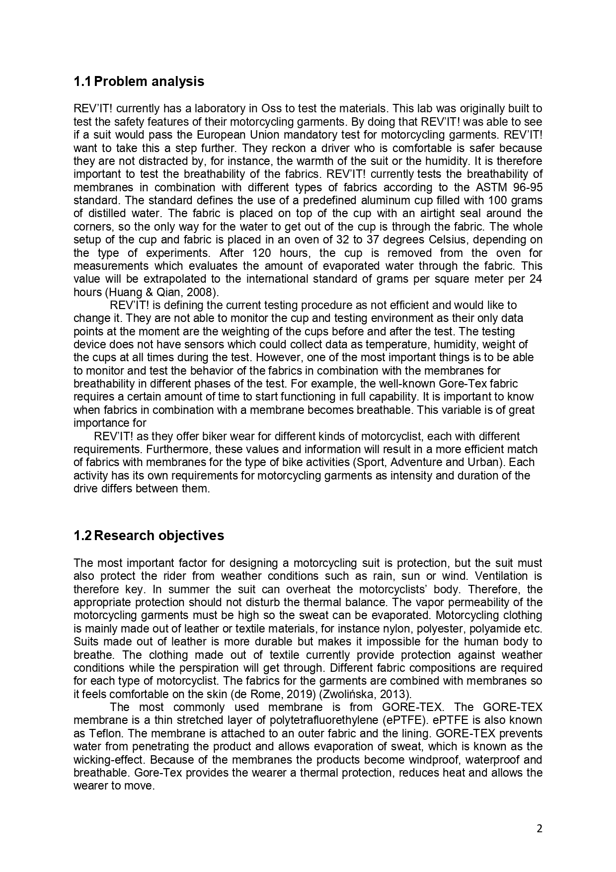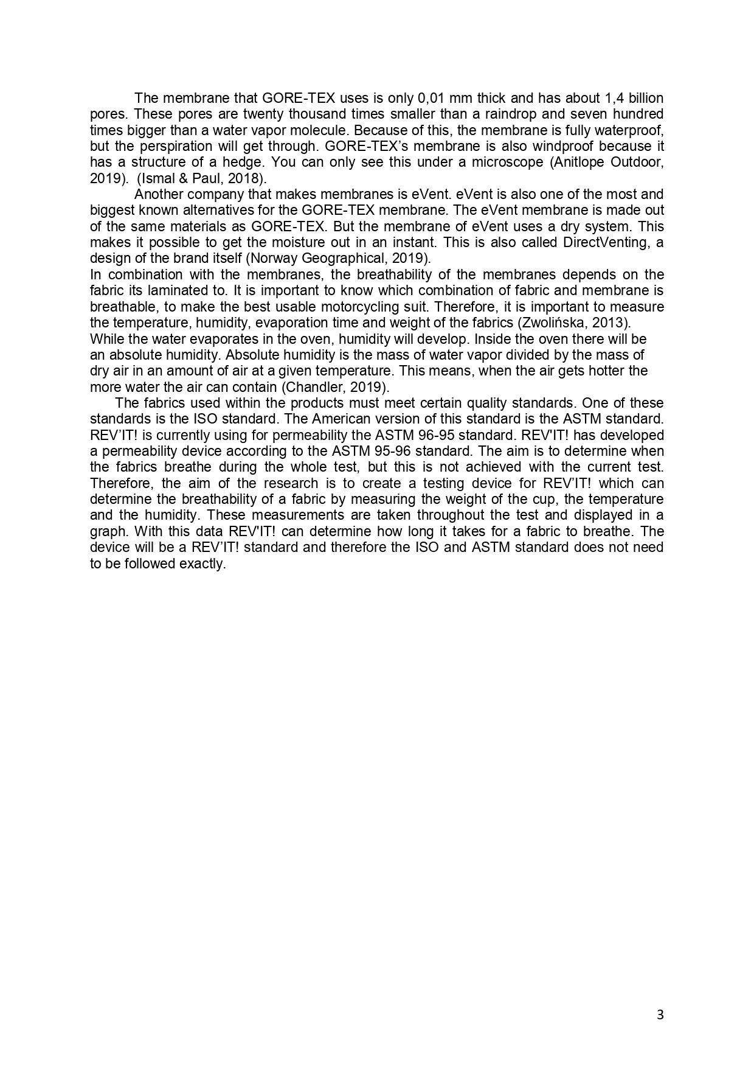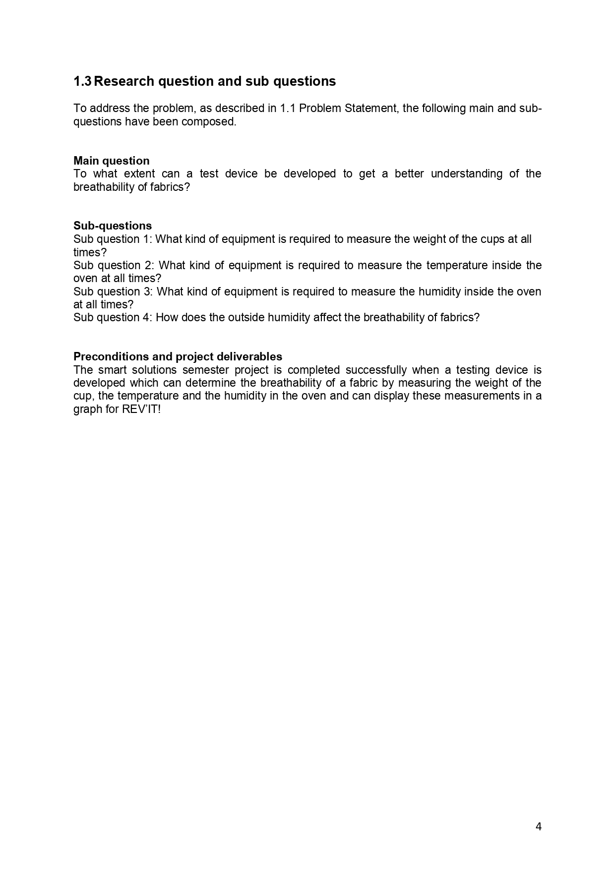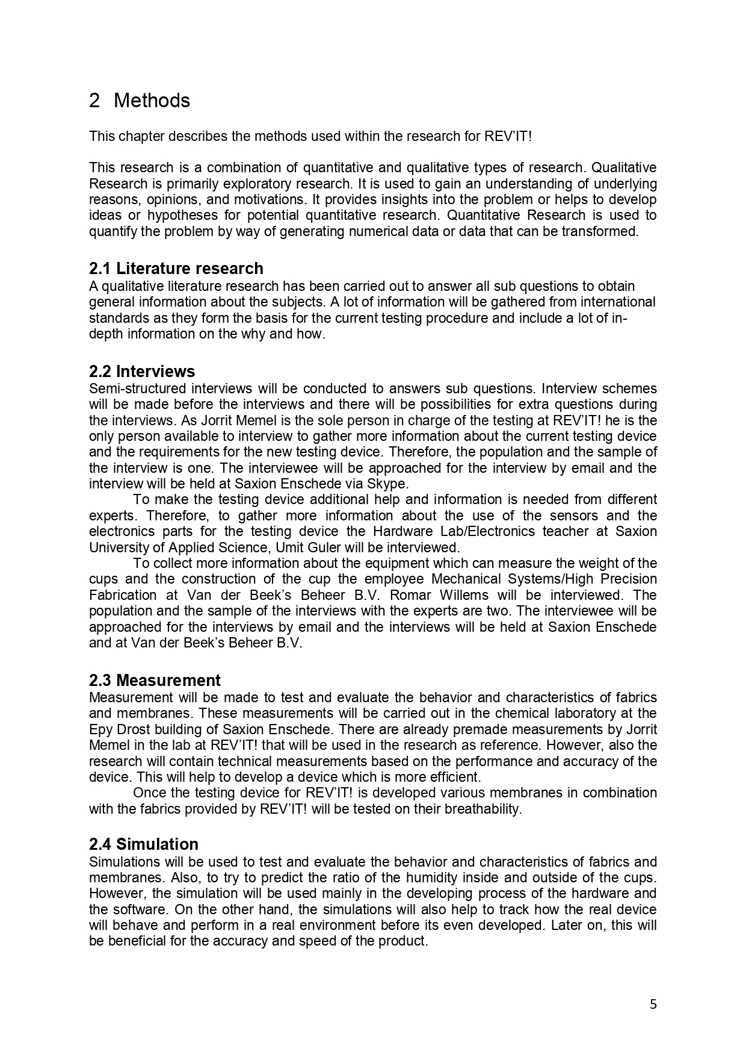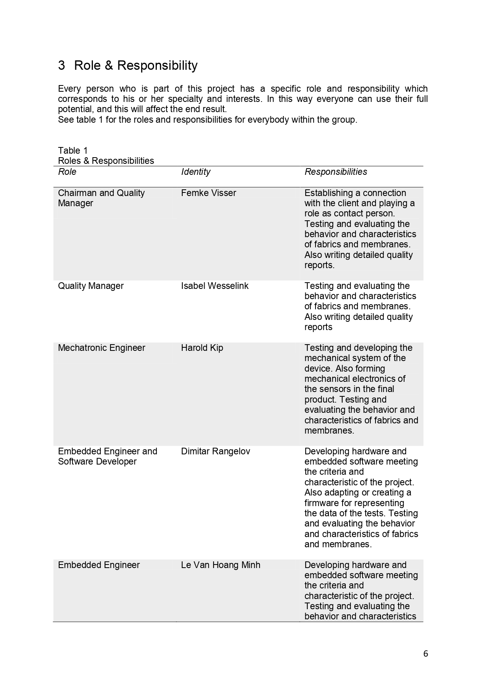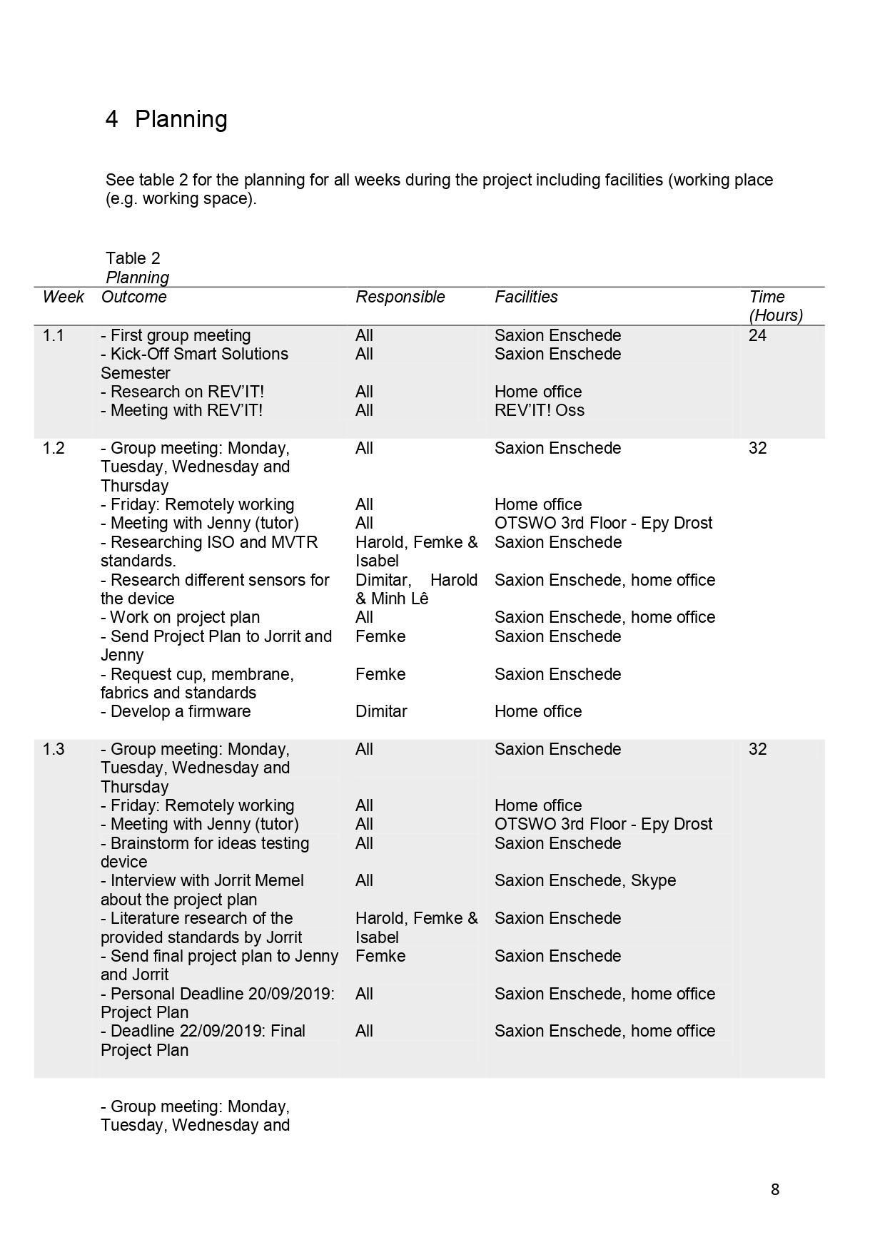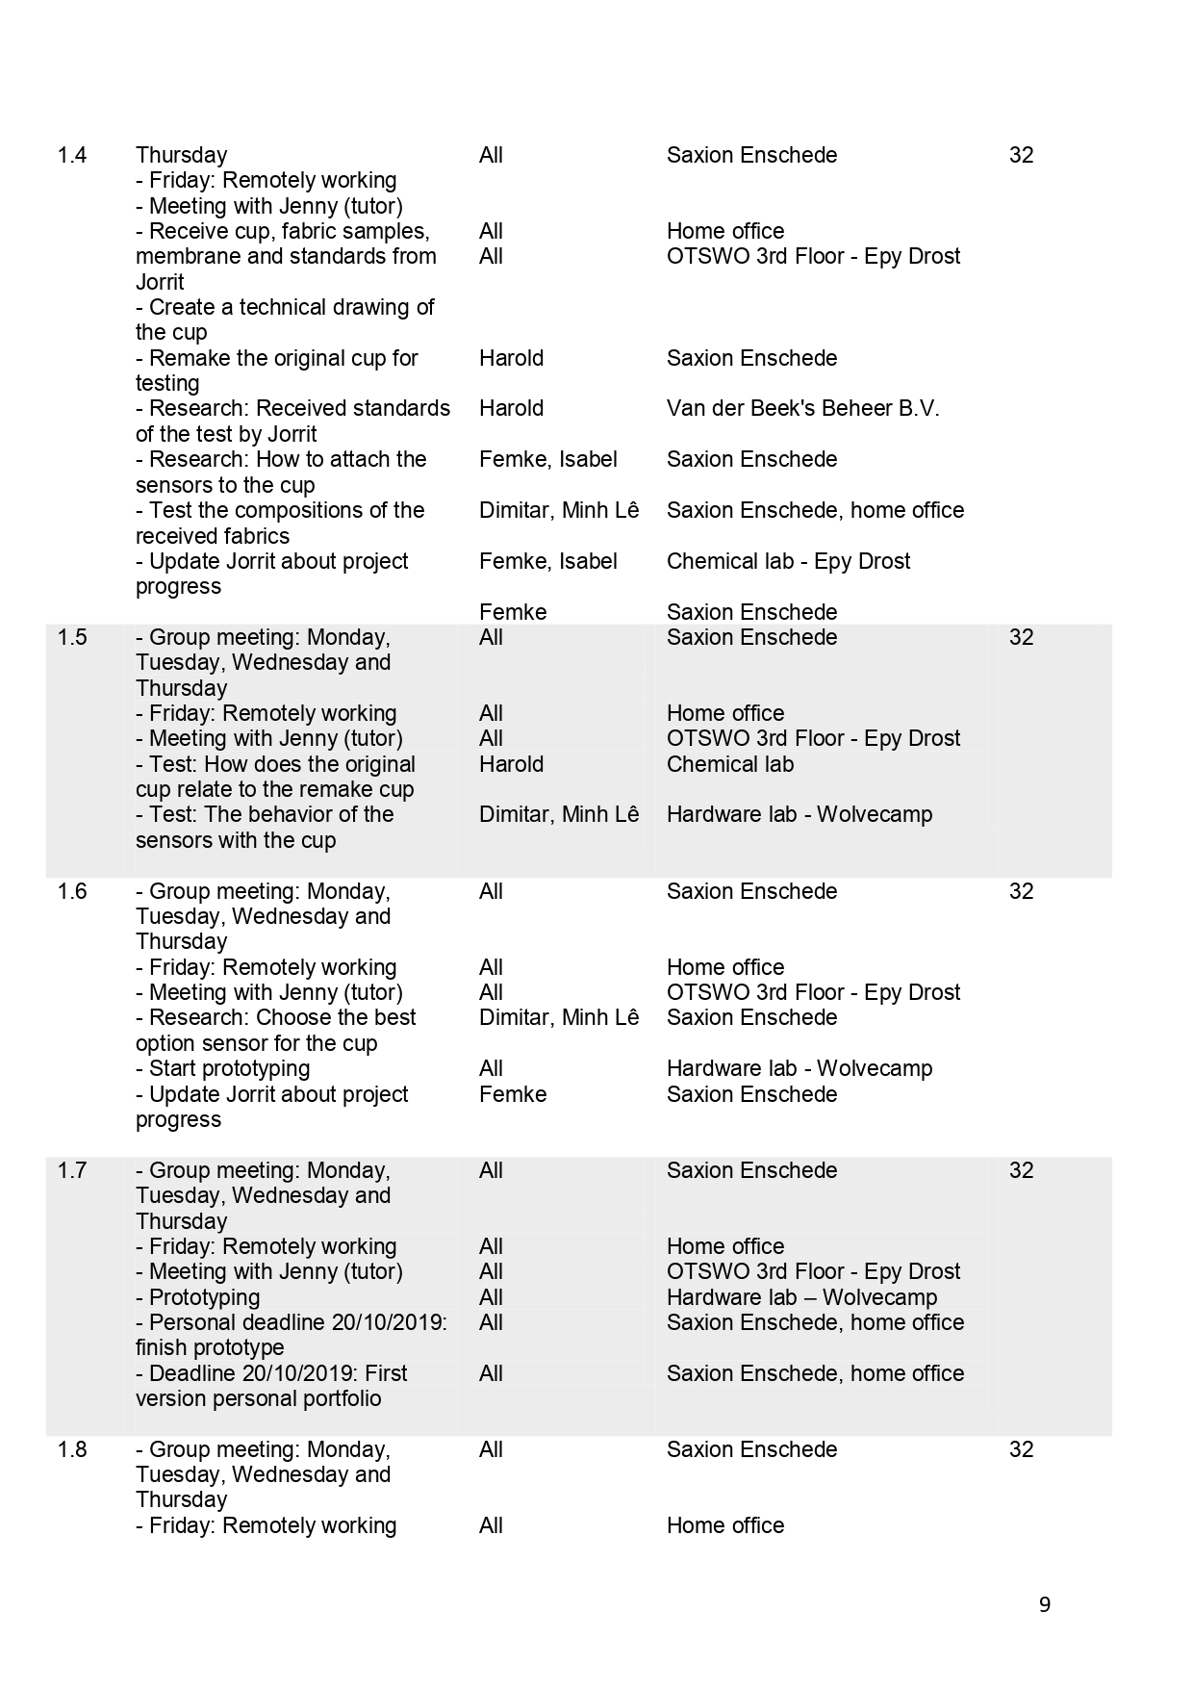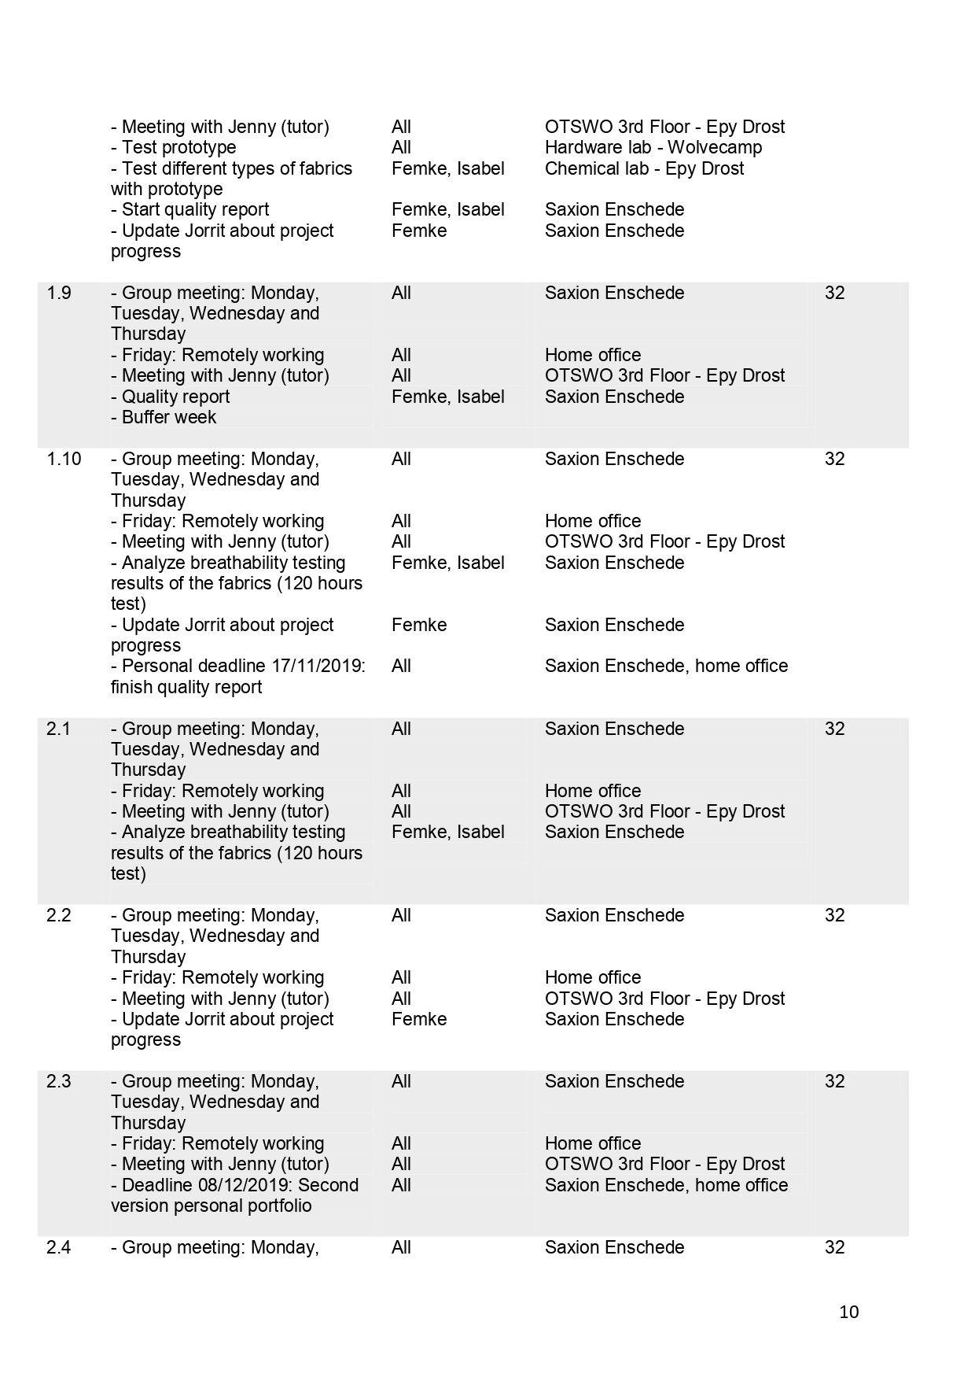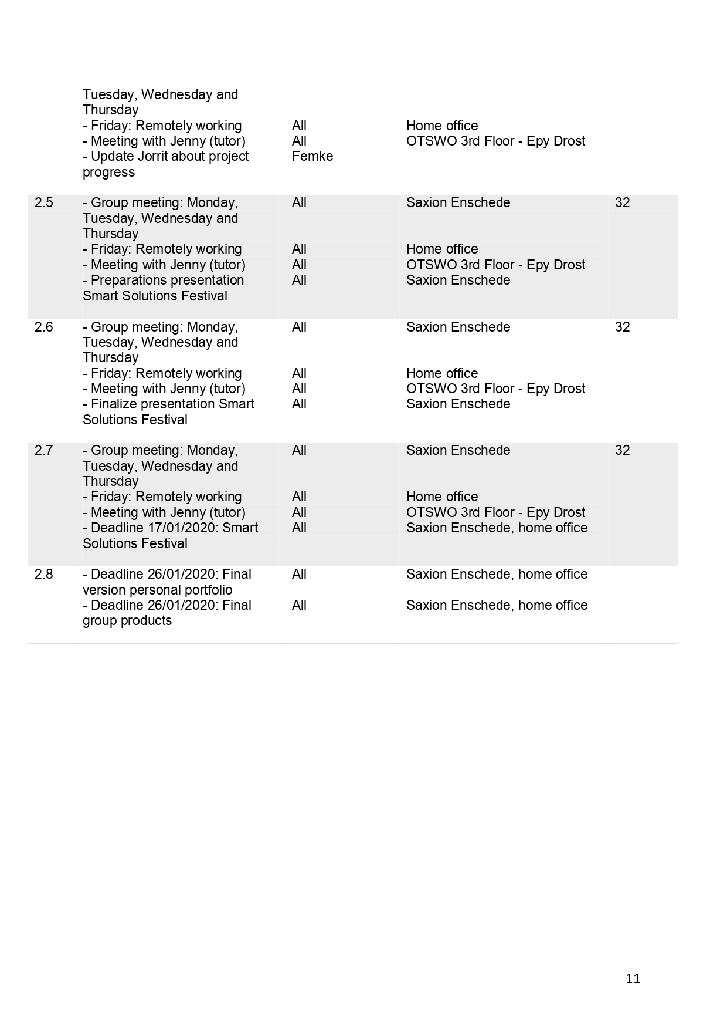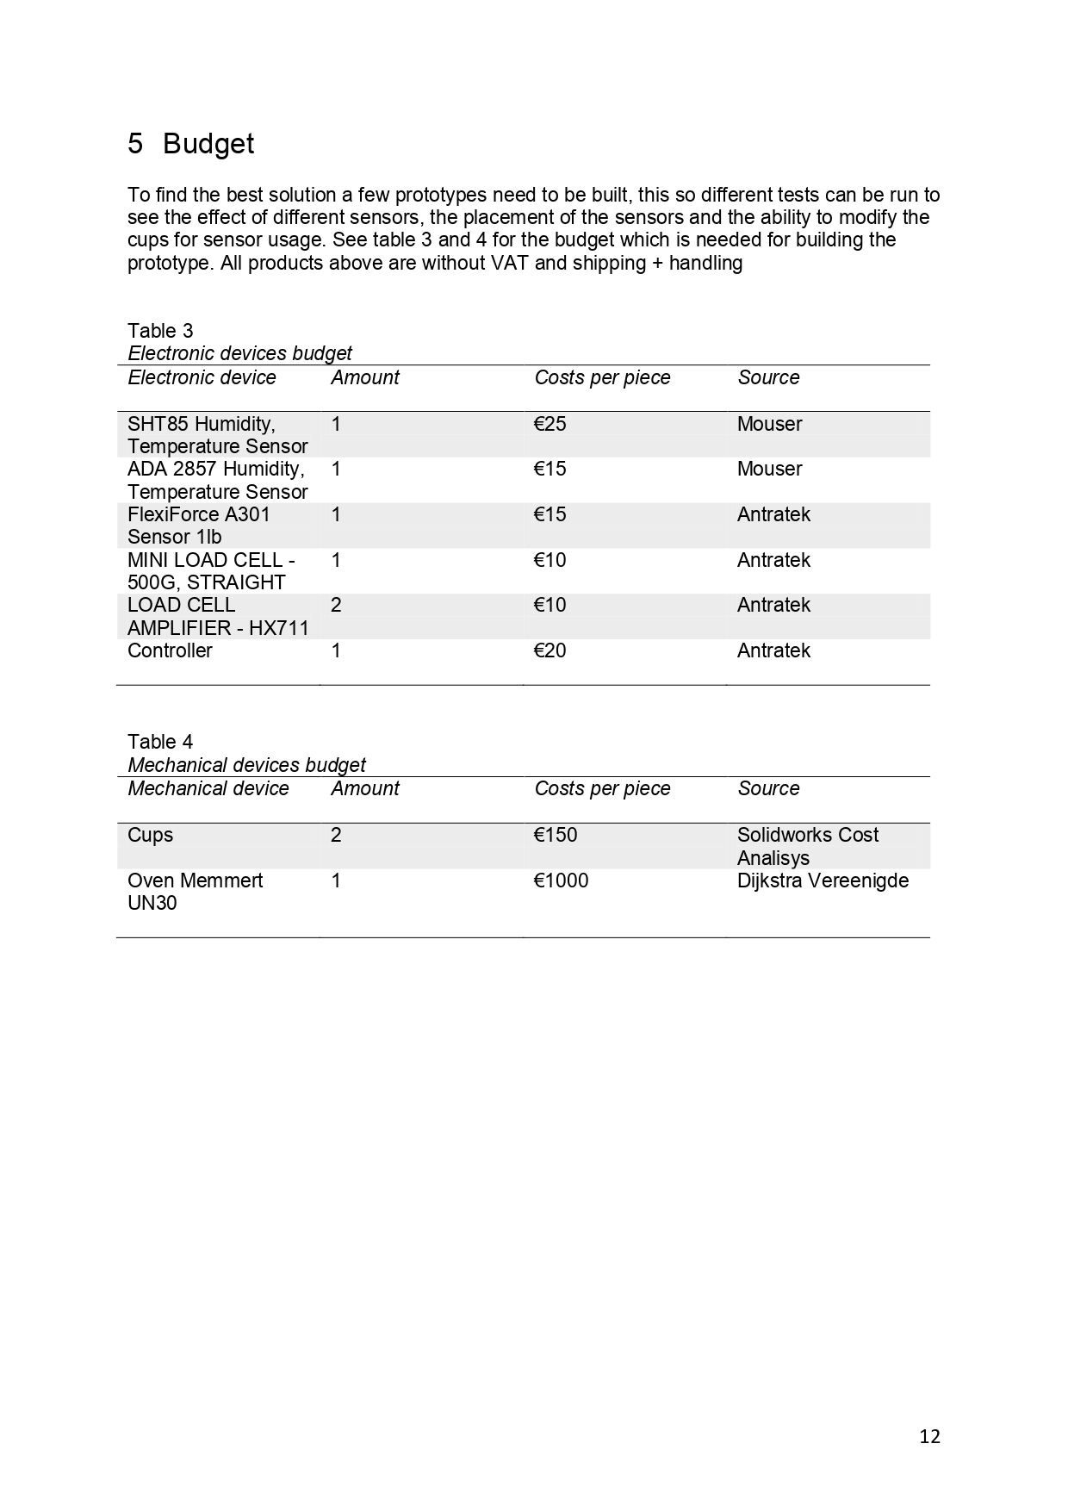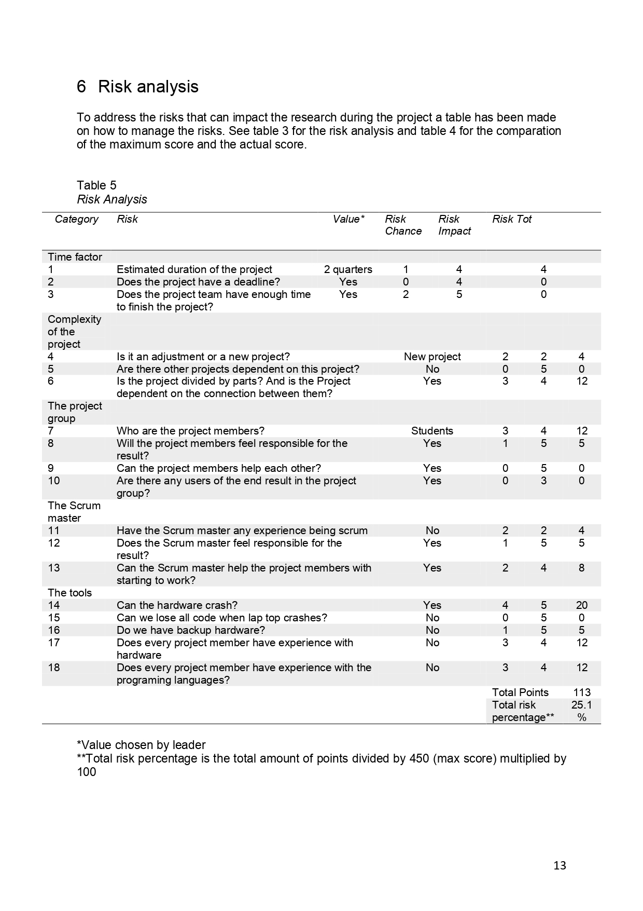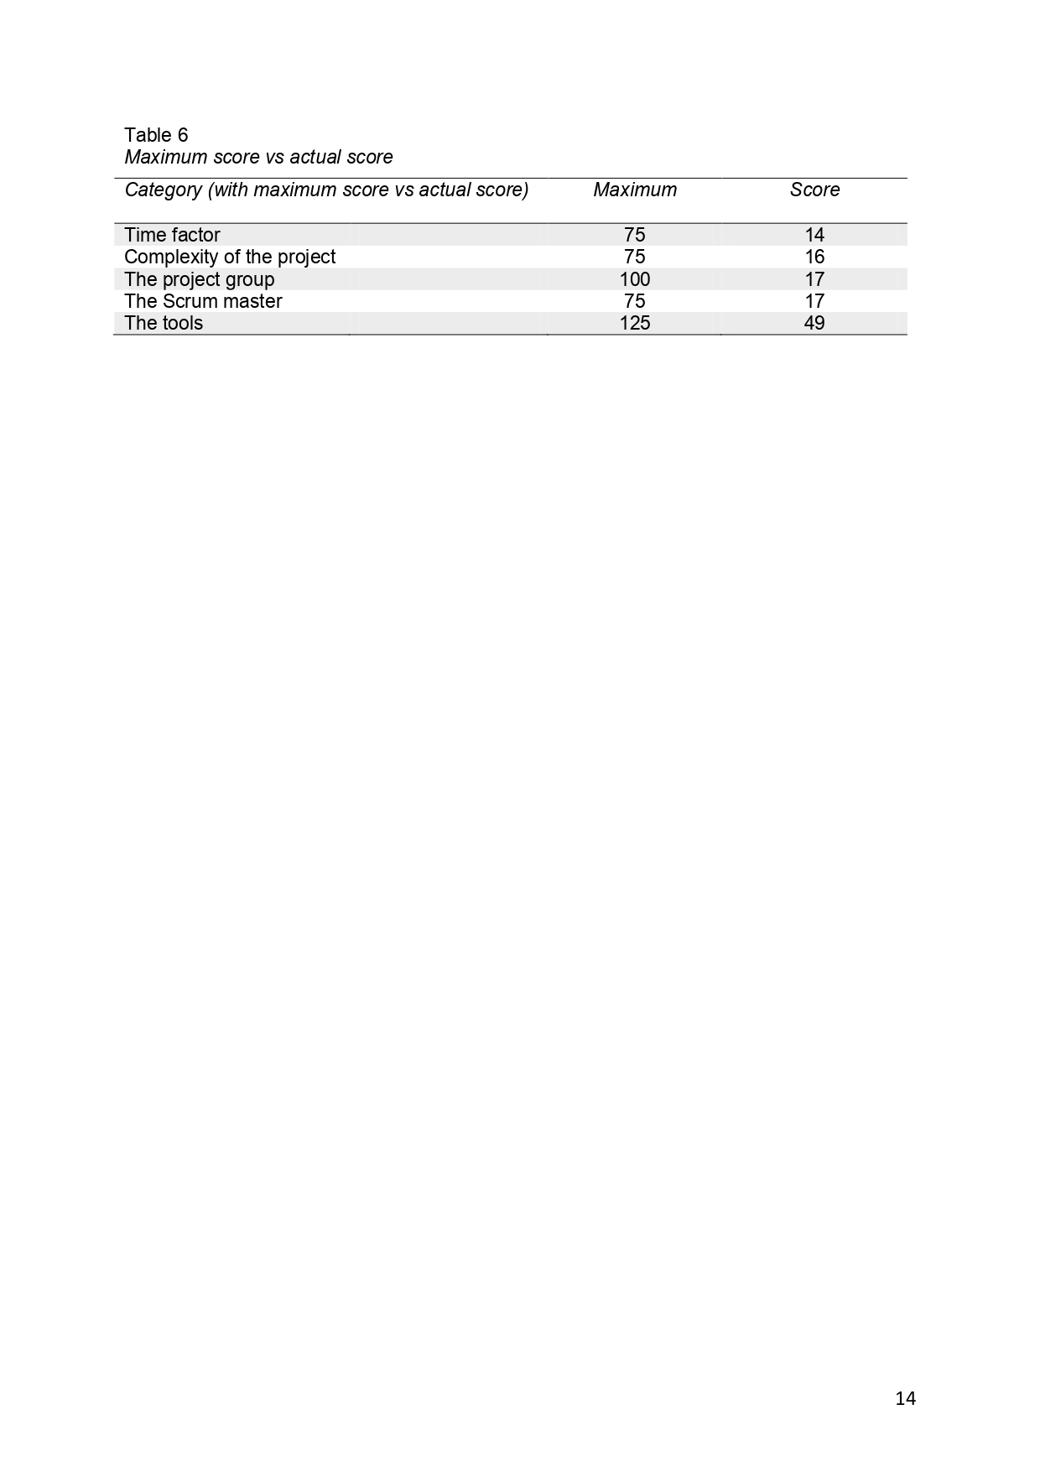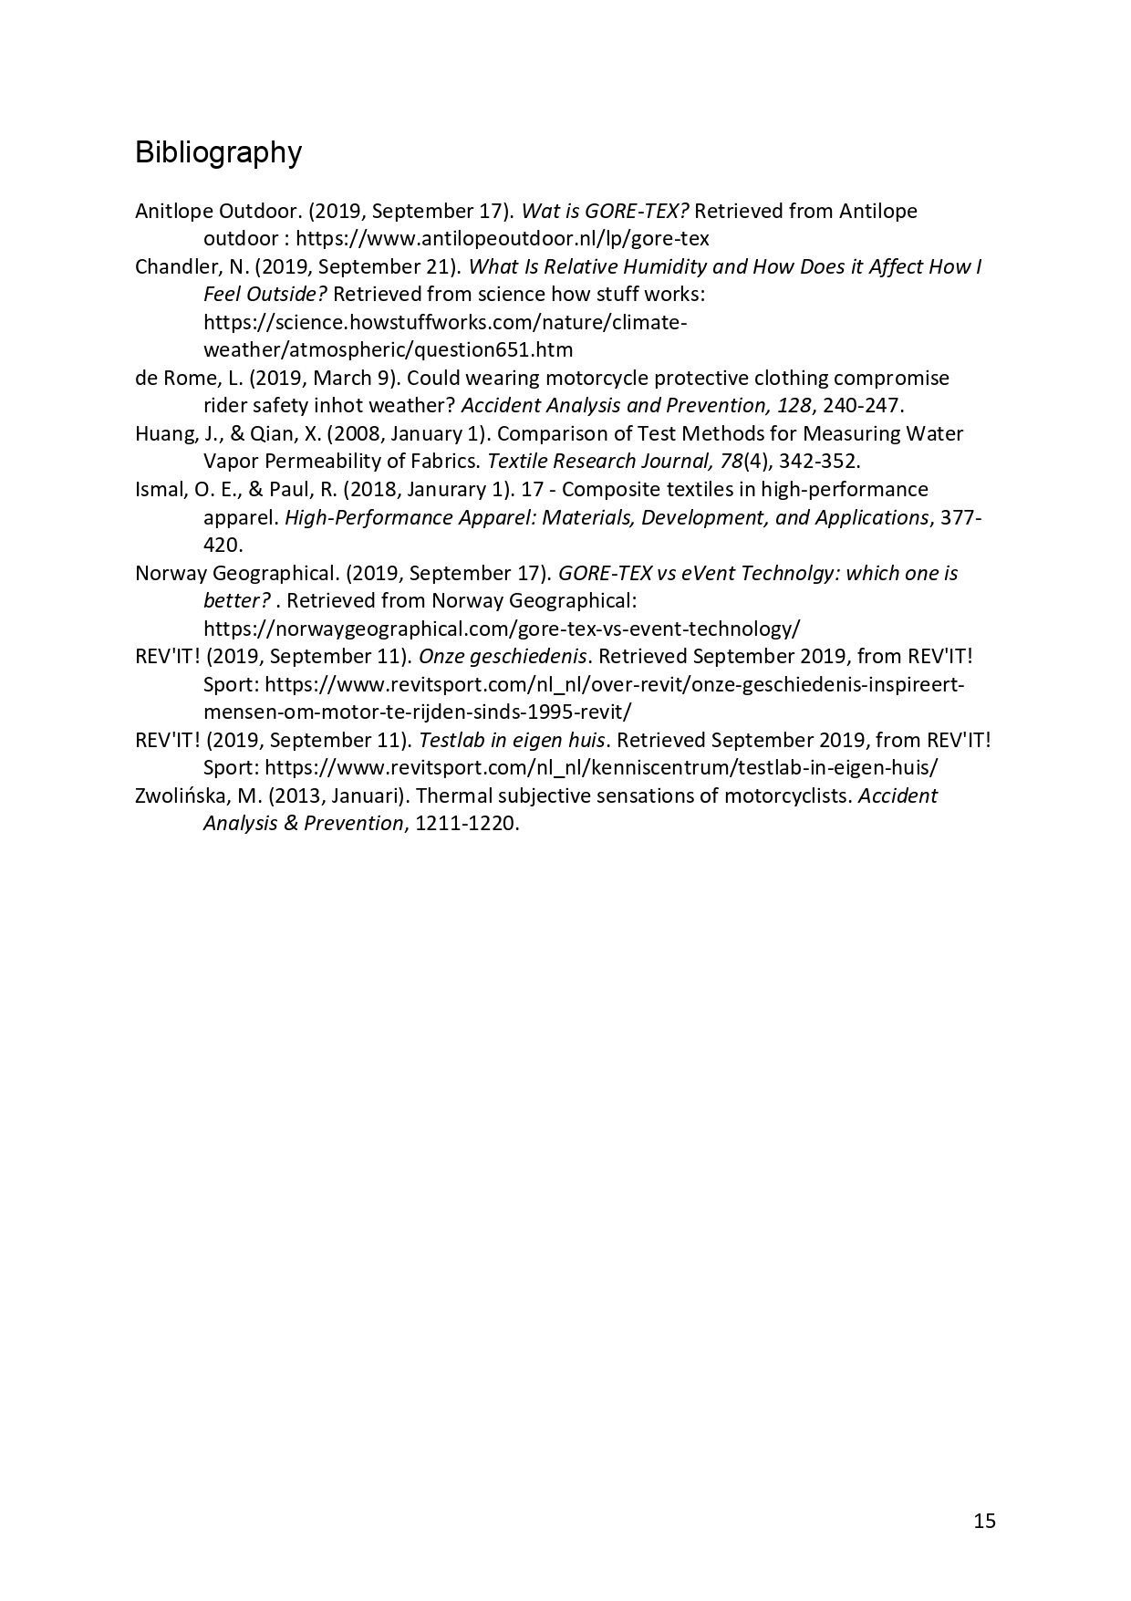

# 9. Technical Research



